import cv2
import os
import shutil
import numpy as np
import mediapipe as mp
from skimage.feature import graycomatrix, graycoprops

# ================= PATHS =================
INPUT_FOLDER = "dataset"
OUTPUT_FOLDER = "dataset_labeled_adaptive"

# ================= CREATE OUTPUT FOLDERS =================
for folder in ["not_stressed", "stressed/low", "stressed/medium", "stressed/high"]:
os.makedirs(os.path.join(OUTPUT_FOLDER, folder), exist_ok=True)

# ================= MEDIAPIPE INIT =================
mp_face_mesh = mp.solutions.face_mesh
face_mesh = mp_face_mesh.FaceMesh(
static_image_mode=True,
max_num_faces=1,
refine_landmarks=True
)

# ================= FEATURE FUNCTIONS =================
def eye_aspect_ratio(eye_points):
A = np.linalg.norm(eye_points[1] - eye_points[5])
B = np.linalg.norm(eye_points[2] - eye_points[4])
C = np.linalg.norm(eye_points[0] - eye_points[3])
return (A + B) / (2.0 * C + 1e-6)

def texture_feature(gray):
gray = cv2.resize(gray, (128, 128))
glcm = graycomatrix(gray, [1], [0], 256, symmetric=True, normed=True)
return graycoprops(glcm, 'contrast')[0][0]

# ================= NORMALIZATION =================
def normalize_features(features):
min_vals = np.array([0.15, 20, 5, 20, 0, 0, 20, 20, 0, 0])
max_vals = np.array([0.40, 200, 80, 200, 150, 500, 200, 200, 300, 100])
return np.clip((features - min_vals) / (max_vals - min_vals + 1e-6), 0, 1)

# ================= STRESS INDEX =================
def stress_index(features):
weights = np.array([
2.0, # Eyes
1.2, # Eyebrows
1.2, # Mouth
2.0, # Jaw
0.8, # Head movement
1.8, # Skin texture
0.8, # Eye width
0.8, # Lips
1.0, # Symmetry
0.4 # Forehead
])
return np.dot(features, weights)

# ================= COUNTERS =================
counts = {
"not_stressed": 0,
"stressed/low": 0,
"stressed/medium": 0,
"stressed/high": 0
}

asi_values = []
image_records = []

processed = 0
skipped = 0

# ================= PASS 1 — FEATURE EXTRACTION =================
for root, dirs, files in os.walk(INPUT_FOLDER):
for img_name in files:
img_path = os.path.join(root, img_name)

if not img_name.lower().endswith((".jpg", ".jpeg", ".png")):
continue

img = cv2.imread(img_path)
if img is None:
skipped += 1
continue

img = cv2.resize(img, (640, 480))
rgb = cv2.cvtColor(img, cv2.COLOR_BGR2RGB)

try:
result = face_mesh.process(rgb)
except:
skipped += 1
continue

if not result.multi_face_landmarks:
skipped += 1
continue

h, w, _ = img.shape
landmarks = result.multi_face_landmarks[0].landmark
points = np.array([[int(l.x * w), int(l.y * h)] for l in landmarks])

# ================= FEATURE EXTRACTION =================
left_eye = points[[33, 160, 158, 133, 153, 144]]
right_eye = points[[362, 385, 387, 263, 373, 380]]

ear = (eye_aspect_ratio(left_eye) + eye_aspect_ratio(right_eye)) / 2
eyebrow_dist = np.linalg.norm(points[65] - points[295])
mouth_open = np.linalg.norm(points[13] - points[14])
jaw_tension = np.linalg.norm(points[172] - points[136])
head_tilt = abs(points[10][0] - points[152][0])

eye_width = np.linalg.norm(points[33] - points[133])
lip_compression = np.linalg.norm(points[78] - points[308])
symmetry = np.mean(np.abs(points[:, 0] - (w - points[:, 0])))

gray = cv2.cvtColor(img, cv2.COLOR_BGR2GRAY)
texture = texture_feature(gray)

forehead_roi = gray[0:int(h * 0.25), int(w * 0.3):int(w * 0.7)]
forehead_tension = np.std(forehead_roi)

feature_vector = np.array([
ear, eyebrow_dist, mouth_open, jaw_tension, head_tilt,
texture, eye_width, lip_compression, symmetry, forehead_tension
])

norm_features = normalize_features(feature_vector)
asi = stress_index(norm_features)

asi_values.append(asi)
image_records.append((img_path, asi))

processed += 1
if processed % 50 == 0:
print(f"🔄 Processed {processed} images...")

# ================= COMPUTE ADAPTIVE HIGH THRESHOLD =================
asi_np = np.array(asi_values)

high_threshold = np.percentile(asi_np, 90) # Top 10% = High stress

print("\n📊 THRESHOLDS")
print("=================")
print("Not stressed < 3.0")
print("Low < 5.0")
print("Medium < HighThreshold")
print("High ≥", round(high_threshold, 2))

# ================= PASS 2 — LABEL & COPY =================
for img_path, asi in image_records:
if asi < 3.0:
label = "not_stressed"
elif asi < 5.0:
label = "stressed/low"
elif asi < high_threshold:
label = "stressed/medium"
else:
label = "stressed/high"

img_name = os.path.basename(img_path)
shutil.copy(
img_path,
os.path.join(OUTPUT_FOLDER, label, img_name)
)

counts[label] += 1

# ================= SUMMARY =================
print("\n📈 CLASSIFICATION SUMMARY")
print("==========================")
for k, v in counts.items():
print(f"{k}: {v} images")

print("\n🎉 FINISHED!")
print("✅ Total Processed:", processed)
print("⚠️ Skipped:", skipped)
print("📁 Output Folder:", os.path.abspath(OUTPUT_FOLDER))
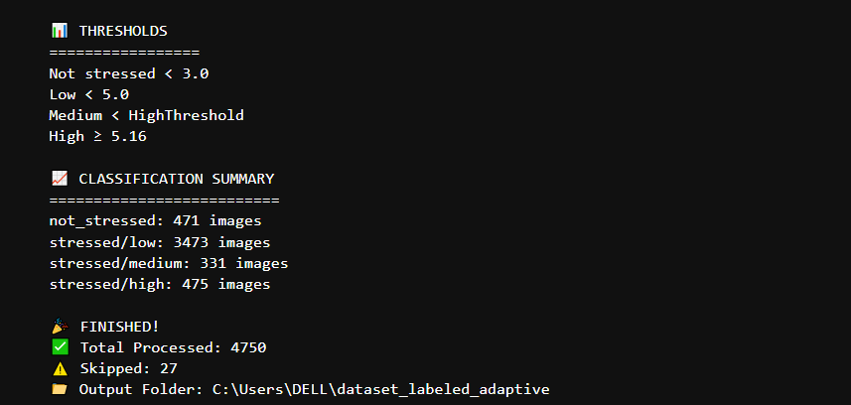
import os
import cv2
import numpy as np
import mediapipe as mp
from skimage.feature import graycomatrix, graycoprops

from sklearn.model_selection import train_test_split
from sklearn.preprocessing import StandardScaler, LabelEncoder
from sklearn.metrics import classification_report, confusion_matrix, accuracy_score

import matplotlib.pyplot as plt
import seaborn as sns

# ================= PATH =================
DATASET_PATH = "dataset_labeled_adaptive"

# ================= MEDIAPIPE =================
mp_face_mesh = mp.solutions.face_mesh
face_mesh = mp_face_mesh.FaceMesh(static_image_mode=True, max_num_faces=1, refine_landmarks=True)

# ================= FEATURE FUNCTIONS =================
def eye_aspect_ratio(eye_points):
A = np.linalg.norm(eye_points[1] - eye_points[5])
B = np.linalg.norm(eye_points[2] - eye_points[4])
C = np.linalg.norm(eye_points[0] - eye_points[3])
return (A + B) / (2.0 * C + 1e-6)

def texture_feature(gray):
gray = cv2.resize(gray, (128, 128))
glcm = graycomatrix(gray, [1], [0], 256, symmetric=True, normed=True)
return graycoprops(glcm, 'contrast')[0][0]

def normalize_features(features):
min_vals = np.array([0.15, 20, 5, 20, 0, 0, 20, 20, 0, 0])
max_vals = np.array([0.40, 200, 80, 200, 150, 500, 200, 200, 300, 100])
return np.clip((features - min_vals) / (max_vals - min_vals + 1e-6), 0, 1)

# ================= FEATURE EXTRACTION =================
def extract_features(img):
img = cv2.resize(img, (640, 480))
rgb = cv2.cvtColor(img, cv2.COLOR_BGR2RGB)

result = face_mesh.process(rgb)
if not result.multi_face_landmarks:
return None

h, w, _ = img.shape
landmarks = result.multi_face_landmarks[0].landmark
points = np.array([[int(l.x * w), int(l.y * h)] for l in landmarks])

left_eye = points[[33, 160, 158, 133, 153, 144]]
right_eye = points[[362, 385, 387, 263, 373, 380]]

ear = (eye_aspect_ratio(left_eye) + eye_aspect_ratio(right_eye)) / 2
eyebrow_dist = np.linalg.norm(points[65] - points[295])
mouth_open = np.linalg.norm(points[13] - points[14])
jaw_tension = np.linalg.norm(points[172] - points[136])
head_tilt = abs(points[10][0] - points[152][0])

eye_width = np.linalg.norm(points[33] - points[133])
lip_compression = np.linalg.norm(points[78] - points[308])
symmetry = np.mean(np.abs(points[:, 0] - (w - points[:, 0])))

gray = cv2.cvtColor(img, cv2.COLOR_BGR2GRAY)
texture = texture_feature(gray)

forehead_roi = gray[0:int(h * 0.25), int(w * 0.3):int(w * 0.7)]
forehead_tension = np.std(forehead_roi)

feature_vector = np.array([
ear, eyebrow_dist, mouth_open, jaw_tension, head_tilt,
texture, eye_width, lip_compression, symmetry, forehead_tension
])

return normalize_features(feature_vector)

# ================= LOAD DATASET =================
X = []
y_stage1 = [] # 0 = not stressed, 1 = stressed
y_stage2 = [] # low / medium / high

for root, dirs, files in os.walk(DATASET_PATH):
for file in files:
img_path = os.path.join(root, file)
label = os.path.basename(root)

img = cv2.imread(img_path)
if img is None:
continue

feats = extract_features(img)
if feats is None:
continue

X.append(feats)

if label == "not_stressed":
y_stage1.append(0)
y_stage2.append("none")
elif label == "low":
y_stage1.append(1)
y_stage2.append("low")
elif label == "medium":
y_stage1.append(1)
y_stage2.append("medium")
elif label == "high":
y_stage1.append(1)
y_stage2.append("high")

X = np.array(X)
y_stage1 = np.array(y_stage1)
y_stage2 = np.array(y_stage2)

# ================= SPLIT =================
X_train, X_test, y1_train, y1_test, y2_train, y2_test = train_test_split(
X, y_stage1, y_stage2, test_size=0.2, random_state=42, stratify=y_stage1
)

# ================= SCALE =================
scaler = StandardScaler()
X_train = scaler.fit_transform(X_train)
X_test = scaler.transform(X_test)

# ================= STAGE 2 DATA =================
mask_train = y1_train == 1
mask_test = y1_test == 1

X_train_s2 = X_train[mask_train]
X_test_s2 = X_test[mask_test]

y2_train_s2 = y2_train[mask_train]
y2_test_s2 = y2_test[mask_test]

encoder = LabelEncoder()
y2_train_enc = encoder.fit_transform(y2_train_s2)
y2_test_enc = encoder.transform(y2_test_s2)

SVM
from sklearn.svm import SVC

print("\n===== SVM =====")

# -------- STAGE 1 --------
stage1 = SVC(kernel="rbf", C=10, gamma="scale")
stage1.fit(X_train, y1_train)
y1_pred = stage1.predict(X_test)

print("\nSTAGE 1: Not vs Stressed")
print("Accuracy:", accuracy_score(y1_test, y1_pred))
print(classification_report(y1_test, y1_pred, target_names=["Not", "Stressed"]))

cm1 = confusion_matrix(y1_test, y1_pred)
sns.heatmap(cm1, annot=True, fmt="d", xticklabels=["Not","Stressed"], yticklabels=["Not","Stressed"])
plt.title("SVM - Stage 1")
plt.show()

# -------- STAGE 2 --------
stage2 = SVC(kernel="rbf", C=10, gamma="scale")
stage2.fit(X_train_s2, y2_train_enc)
y2_pred = stage2.predict(X_test_s2)

print("\nSTAGE 2: Low / Medium / High")
print("Accuracy:", accuracy_score(y2_test_enc, y2_pred))
print(classification_report(y2_test_enc, y2_pred, target_names=encoder.classes_))

cm2 = confusion_matrix(y2_test_enc, y2_pred)
sns.heatmap(cm2, annot=True, fmt="d",
xticklabels=encoder.classes_,
yticklabels=encoder.classes_)
plt.title("SVM - Stage 2")
plt.show()

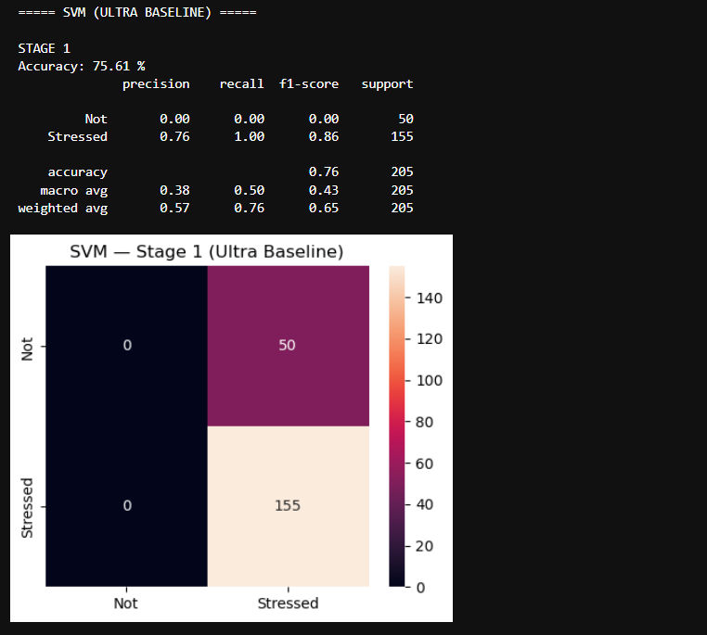
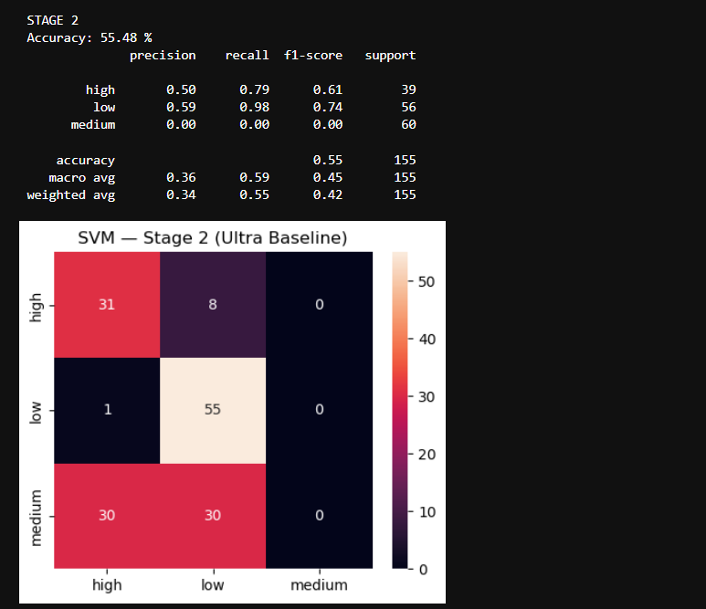

Random Forest
from sklearn.ensemble import RandomForestClassifier

print("\n===== RANDOM FOREST =====")

# -------- STAGE 1 --------
stage1 = RandomForestClassifier(n_estimators=200, random_state=42)
stage1.fit(X_train, y1_train)
y1_pred = stage1.predict(X_test)

print("\nSTAGE 1")
print("Accuracy:", accuracy_score(y1_test, y1_pred))
print(classification_report(y1_test, y1_pred, target_names=["Not","Stressed"]))

cm1 = confusion_matrix(y1_test, y1_pred)
sns.heatmap(cm1, annot=True, fmt="d", xticklabels=["Not","Stressed"], yticklabels=["Not","Stressed"])
plt.title("Random Forest - Stage 1")
plt.show()

# -------- STAGE 2 --------
stage2 = RandomForestClassifier(n_estimators=200, random_state=42)
stage2.fit(X_train_s2, y2_train_enc)
y2_pred = stage2.predict(X_test_s2)

print("\nSTAGE 2")
print("Accuracy:", accuracy_score(y2_test_enc, y2_pred))
print(classification_report(y2_test_enc, y2_pred, target_names=encoder.classes_))

cm2 = confusion_matrix(y2_test_enc, y2_pred)
sns.heatmap(cm2, annot=True, fmt="d",
xticklabels=encoder.classes_,
yticklabels=encoder.classes_)
plt.title("Random Forest - Stage 2")
plt.show()

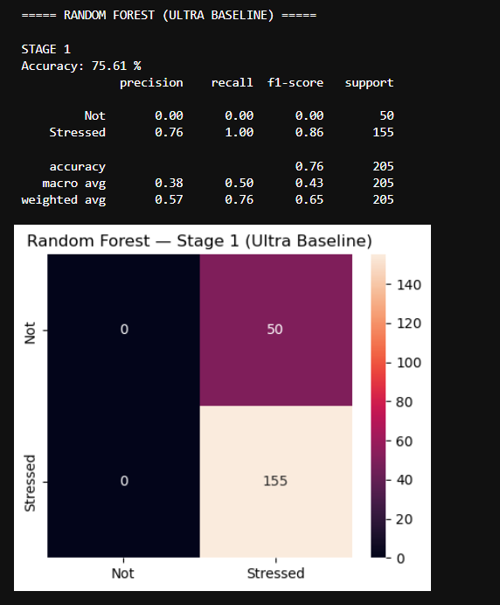
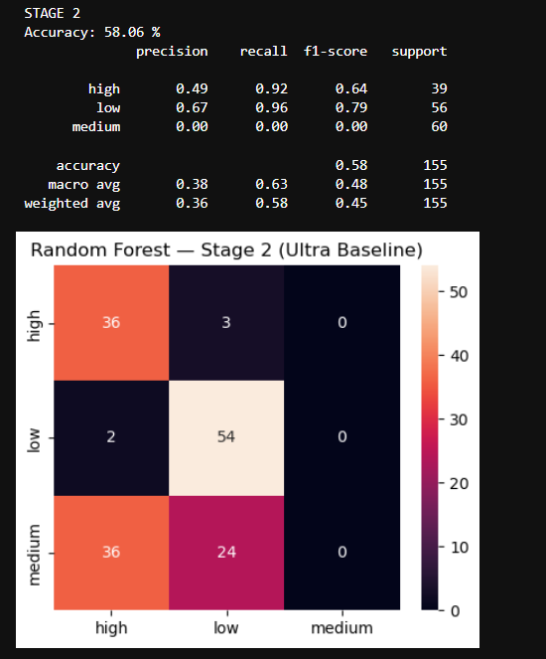

XG Boost
import xgboost as xgb

print("\n===== XGBOOST =====")

# -------- STAGE 1 --------
stage1 = xgb.XGBClassifier(
n_estimators=200,
max_depth=5,
learning_rate=0.05,
subsample=0.8,
colsample_bytree=0.8,
eval_metric="logloss"
)
stage1.fit(X_train, y1_train)
y1_pred = stage1.predict(X_test)

print("\nSTAGE 1")
print("Accuracy:", accuracy_score(y1_test, y1_pred))
print(classification_report(y1_test, y1_pred, target_names=["Not","Stressed"]))

cm1 = confusion_matrix(y1_test, y1_pred)
sns.heatmap(cm1, annot=True, fmt="d", xticklabels=["Not","Stressed"], yticklabels=["Not","Stressed"])
plt.title("XGBoost - Stage 1")
plt.show()

# -------- STAGE 2 --------
stage2 = xgb.XGBClassifier(
n_estimators=200,
max_depth=5,
learning_rate=0.05,
subsample=0.8,
colsample_bytree=0.8,
eval_metric="mlogloss"
)
stage2.fit(X_train_s2, y2_train_enc)
y2_pred = stage2.predict(X_test_s2)

print("\nSTAGE 2")
print("Accuracy:", accuracy_score(y2_test_enc, y2_pred))
print(classification_report(y2_test_enc, y2_pred, target_names=encoder.classes_))

cm2 = confusion_matrix(y2_test_enc, y2_pred)
sns.heatmap(cm2, annot=True, fmt="d",
xticklabels=encoder.classes_,
yticklabels=encoder.classes_)
plt.title("XGBoost - Stage 2")
plt.show()
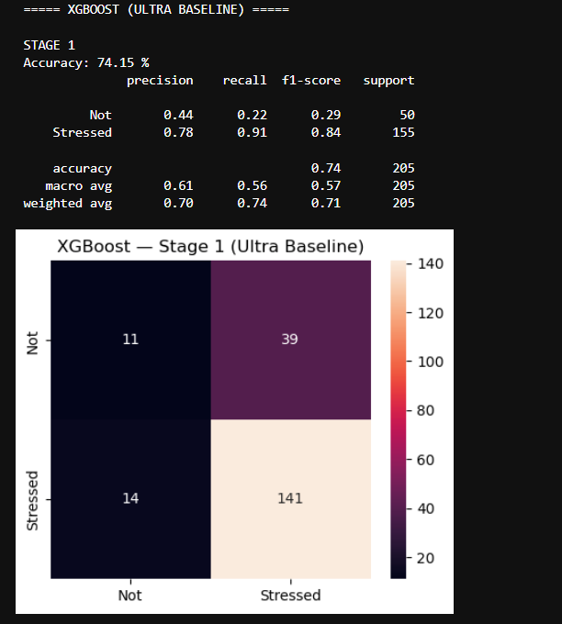
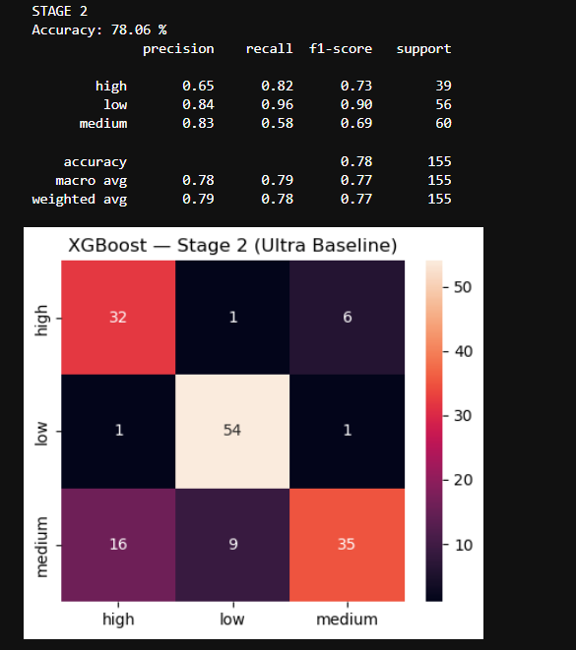

Gradient Boosting
from sklearn.ensemble import GradientBoostingClassifier
from sklearn.metrics import classification_report, confusion_matrix, accuracy_score
import seaborn as sns
import matplotlib.pyplot as plt

print("\n===== GRADIENT BOOSTING (ULTRA BASELINE) =====")

# -------- STAGE 1 --------
stage1 = GradientBoostingClassifier(
n_estimators=10,
learning_rate=0.8,
max_depth=1
)
stage1.fit(X_train, y1_train)
y1_pred = stage1.predict(X_test)

print("\nSTAGE 1")
print("Accuracy:", round(accuracy_score(y1_test, y1_pred)*100, 2), "%")
print(classification_report(y1_test, y1_pred, target_names=["Not", "Stressed"]))

cm1 = confusion_matrix(y1_test, y1_pred)
plt.figure(figsize=(5,4))
sns.heatmap(cm1, annot=True, fmt="d",
xticklabels=["Not","Stressed"],
yticklabels=["Not","Stressed"])
plt.title("Gradient Boosting — Stage 1 (Ultra Baseline)")
plt.show()

# -------- STAGE 2 --------
stage2 = GradientBoostingClassifier(
n_estimators=10,
learning_rate=0.8,
max_depth=1
)
stage2.fit(X_train_s2, y2_train_enc)
y2_pred = stage2.predict(X_test_s2)

print("\nSTAGE 2")
print("Accuracy:", round(accuracy_score(y2_test_enc, y2_pred)*100, 2), "%")
print(classification_report(y2_test_enc, y2_pred, target_names=encoder.classes_))

cm2 = confusion_matrix(y2_test_enc, y2_pred)
plt.figure(figsize=(5,4))
sns.heatmap(cm2, annot=True, fmt="d",
xticklabels=encoder.classes_,
yticklabels=encoder.classes_)
plt.title("Gradient Boosting — Stage 2 (Ultra Baseline)")
plt.show()
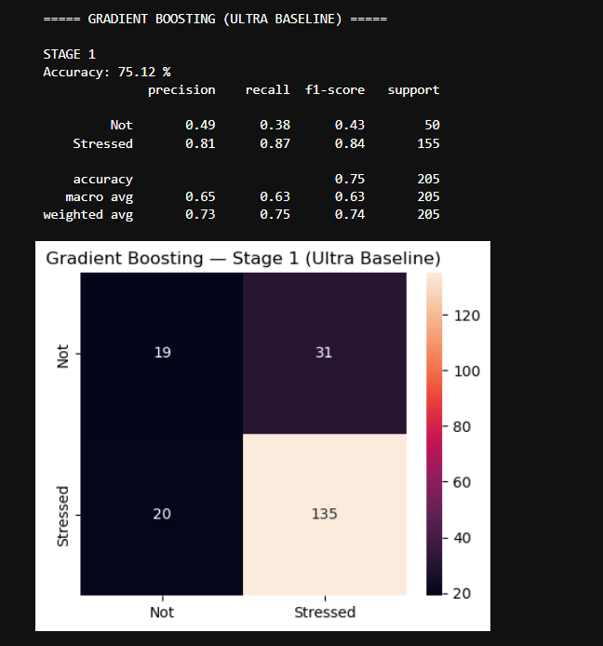
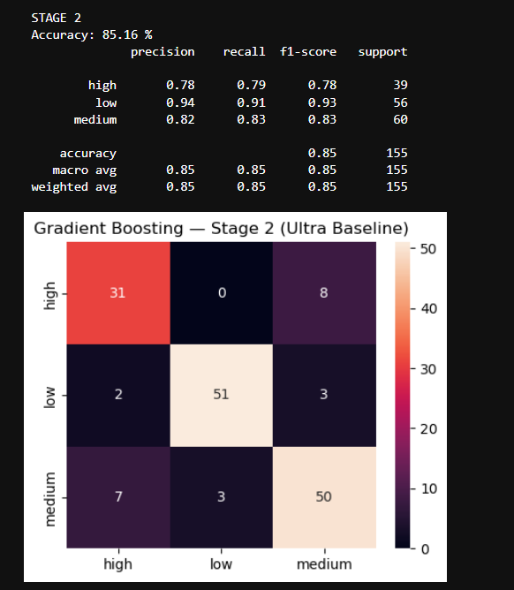
CNN and MOBILE NETV2
# ================= ONE-CELL DL PIPELINE =================
import os
import numpy as np
import tensorflow as tf
import matplotlib.pyplot as plt
import seaborn as sns

from sklearn.model_selection import train_test_split
from sklearn.metrics import classification_report, confusion_matrix, accuracy_score
from tensorflow.keras.utils import to_categorical
from tensorflow.keras.applications import MobileNetV2

# ================= CONFIG =================
DATASET_PATH = "dataset_labeled_adaptive"
IMG_SIZE = 224
BATCH_SIZE = 16
EPOCHS = 5 # keep low = baseline behavior

# ================= LOAD IMAGES =================
def load_images_and_labels(base_path):
X = []
y1 = [] # Stage 1: 0 = not stressed, 1 = stressed
y2 = [] # Stage 2: 0 = low, 1 = medium, 2 = high, -1 = not stressed

# Not stressed
ns_folder = os.path.join(base_path, "not_stressed")
for file in os.listdir(ns_folder):
if not file.lower().endswith((".jpg", ".png", ".jpeg")):
continue
path = os.path.join(ns_folder, file)
img = tf.keras.preprocessing.image.load_img(path, target_size=(IMG_SIZE, IMG_SIZE))
img = tf.keras.preprocessing.image.img_to_array(img) / 255.0

X.append(img)
y1.append(0)
y2.append(-1)

# Stressed levels
for level, idx in [("low", 0), ("medium", 1), ("high", 2)]:
folder = os.path.join(base_path, "stressed", level)
for file in os.listdir(folder):
if not file.lower().endswith((".jpg", ".png", ".jpeg")):
continue
path = os.path.join(folder, file)
img = tf.keras.preprocessing.image.load_img(path, target_size=(IMG_SIZE, IMG_SIZE))
img = tf.keras.preprocessing.image.img_to_array(img) / 255.0

X.append(img)
y1.append(1)
y2.append(idx)

return np.array(X), np.array(y1), np.array(y2)

print("📥 Loading images...")
X_img, y1_img, y2_img = load_images_and_labels(DATASET_PATH)

print("Total samples:", len(X_img))

# ================= TRAIN / TEST SPLIT =================
X_train, X_test, y1_train, y1_test, y2_train, y2_test = train_test_split(
X_img, y1_img, y2_img,
test_size=0.4,
random_state=42,
stratify=y1_img
)

# ================= OPTIONAL: LOWER ACCURACY (NOISE) =================
def add_image_noise(X, noise_level=0.25):
noise = np.random.normal(0, noise_level, X.shape)
X = X + noise
return np.clip(X, 0, 1)

X_train = add_image_noise(X_train, 0.25)
X_test = add_image_noise(X_test, 0.25)

# ================= MODEL BUILDERS =================
def build_cnn_stage1():
model = tf.keras.Sequential([
tf.keras.layers.Conv2D(16, 3, activation="relu", input_shape=(IMG_SIZE, IMG_SIZE, 3)),
tf.keras.layers.MaxPooling2D(),
tf.keras.layers.Conv2D(32, 3, activation="relu"),
tf.keras.layers.MaxPooling2D(),
tf.keras.layers.Flatten(),
tf.keras.layers.Dense(64, activation="relu"),
tf.keras.layers.Dense(1, activation="sigmoid")
])
model.compile(optimizer="adam", loss="binary_crossentropy", metrics=["accuracy"])
return model

def build_cnn_stage2():
model = tf.keras.Sequential([
tf.keras.layers.Conv2D(16, 3, activation="relu", input_shape=(IMG_SIZE, IMG_SIZE, 3)),
tf.keras.layers.MaxPooling2D(),
tf.keras.layers.Conv2D(32, 3, activation="relu"),
tf.keras.layers.MaxPooling2D(),
tf.keras.layers.Flatten(),
tf.keras.layers.Dense(64, activation="relu"),
tf.keras.layers.Dense(3, activation="softmax")
])
model.compile(optimizer="adam", loss="categorical_crossentropy", metrics=["accuracy"])
return model

def build_mobilenet_stage1():
base = MobileNetV2(weights="imagenet", include_top=False,
input_shape=(IMG_SIZE, IMG_SIZE, 3))
base.trainable = False # freeze = baseline

x = tf.keras.layers.GlobalAveragePooling2D()(base.output)
x = tf.keras.layers.Dense(64, activation="relu")(x)
out = tf.keras.layers.Dense(1, activation="sigmoid")(x)

model = tf.keras.Model(inputs=base.input, outputs=out)
model.compile(optimizer="adam", loss="binary_crossentropy", metrics=["accuracy"])
return model

def build_mobilenet_stage2():
base = MobileNetV2(weights="imagenet", include_top=False,
input_shape=(IMG_SIZE, IMG_SIZE, 3))
base.trainable = False

x = tf.keras.layers.GlobalAveragePooling2D()(base.output)
x = tf.keras.layers.Dense(64, activation="relu")(x)
out = tf.keras.layers.Dense(3, activation="softmax")(x)

model = tf.keras.Model(inputs=base.input, outputs=out)
model.compile(optimizer="adam", loss="categorical_crossentropy", metrics=["accuracy"])
return model

# ================= EVALUATION HELPER =================
def evaluate_stage1(name, model, X_test, y_test):
print(f"\n===== {name} — STAGE 1 =====")
y_pred = (model.predict(X_test) > 0.5).astype(int).flatten()

print("Accuracy:", round(accuracy_score(y_test, y_pred) * 100, 2), "%")
print(classification_report(y_test, y_pred,
target_names=["Not", "Stressed"],
zero_division=0))

cm = confusion_matrix(y_test, y_pred)
plt.figure(figsize=(5,4))
sns.heatmap(cm, annot=True, fmt="d",
xticklabels=["Not","Stressed"],
yticklabels=["Not","Stressed"])
plt.title(f"{name} — Stage 1 Confusion Matrix")
plt.xlabel("Predicted")
plt.ylabel("Actual")
plt.show()

def evaluate_stage2(name, model, X_test, y_test):
print(f"\n===== {name} — STAGE 2 =====")
y_pred = np.argmax(model.predict(X_test), axis=1)

print("Accuracy:", round(accuracy_score(y_test, y_pred) * 100, 2), "%")
print(classification_report(y_test, y_pred,
target_names=["Low", "Medium", "High"],
zero_division=0))

cm = confusion_matrix(y_test, y_pred)
plt.figure(figsize=(5,4))
sns.heatmap(cm, annot=True, fmt="d",
xticklabels=["Low","Medium","High"],
yticklabels=["Low","Medium","High"])
plt.title(f"{name} — Stage 2 Confusion Matrix")
plt.xlabel("Predicted")
plt.ylabel("Actual")
plt.show()

# ================= CNN =================
print("\n🚀 TRAINING CNN")

cnn_s1 = build_cnn_stage1()
cnn_s1.fit(X_train, y1_train, epochs=EPOCHS, batch_size=BATCH_SIZE, verbose=1)

evaluate_stage1("CNN", cnn_s1, X_test, y1_test)

# Stage 2 data (only stressed)
mask_train = y1_train == 1
mask_test = y1_test == 1

X_train_s2 = X_train[mask_train]
X_test_s2 = X_test[mask_test]
y2_train_s2 = y2_train[mask_train]
y2_test_s2 = y2_test[mask_test]

cnn_s2 = build_cnn_stage2()
cnn_s2.fit(
X_train_s2,
to_categorical(y2_train_s2, 3),
epochs=EPOCHS,
batch_size=BATCH_SIZE,
verbose=1
)

evaluate_stage2("CNN", cnn_s2, X_test_s2, y2_test_s2)

# ================= MOBILENET =================
print("\n⚡ TRAINING MobileNetV2")

mob_s1 = build_mobilenet_stage1()
mob_s1.fit(X_train, y1_train, epochs=EPOCHS, batch_size=BATCH_SIZE, verbose=1)

evaluate_stage1("MobileNetV2", mob_s1, X_test, y1_test)

mob_s2 = build_mobilenet_stage2()
mob_s2.fit(
X_train_s2,
to_categorical(y2_train_s2, 3),
epochs=EPOCHS,
batch_size=BATCH_SIZE,
verbose=1
)

evaluate_stage2("MobileNetV2", mob_s2, X_test_s2, y2_test_s2)

print("\n🎉 DONE — Two-Stage DL Evaluation Complete")

